PCB Defect Detection Project Report

Milestone 1: Dataset Preparation and Image Processing
This milestone focused on preparing the DeepPCB dataset, aligning template–test image pairs, and creating defect difference maps using image subtraction. The preprocessing involved cleaning the dataset, extracting XML annotations, matching them with corresponding images, and converting bounding boxes into YOLO format. Thresholding (Otsu) and filtering helped enhance defect visibility. Contour detection using OpenCV enabled extraction of ROIs and generating bounding boxes for training. The dataset was successfully split into train/val sets with proper labels.

Milestone 2: Model Training and Evaluation
YOLOv8-S, YOLOv8-S with backbone freezing + finetuning, and YOLOv8-M models were trained. Training involved augmentations, different optimizers (SGD, AdamW), learning rate schedules, mosaic strategies, and mixed precision (AMP). Validation metrics improved significantly across experiments, with YOLOv8-M providing the best stability. Metrics such as mAP50, precision, recall, and class-wise performance were recorded, showing consistent improvements.

Model Performance Summary
Multiple training strategies were tested:
- Baseline YOLOv8-S achieved steady improvements but suffered slight overfitting at later epochs.
- Freeze → Finetune strategy stabilized early layers and produced better generalization.
- YOLOv8-M achieved the best mAP50 ~ 0.94–0.95 with strong recall and stable val loss.
Training logs captured reductions in box, cls, and DFL losses, confirming effective convergence.

1. Yolov8s Result Graph
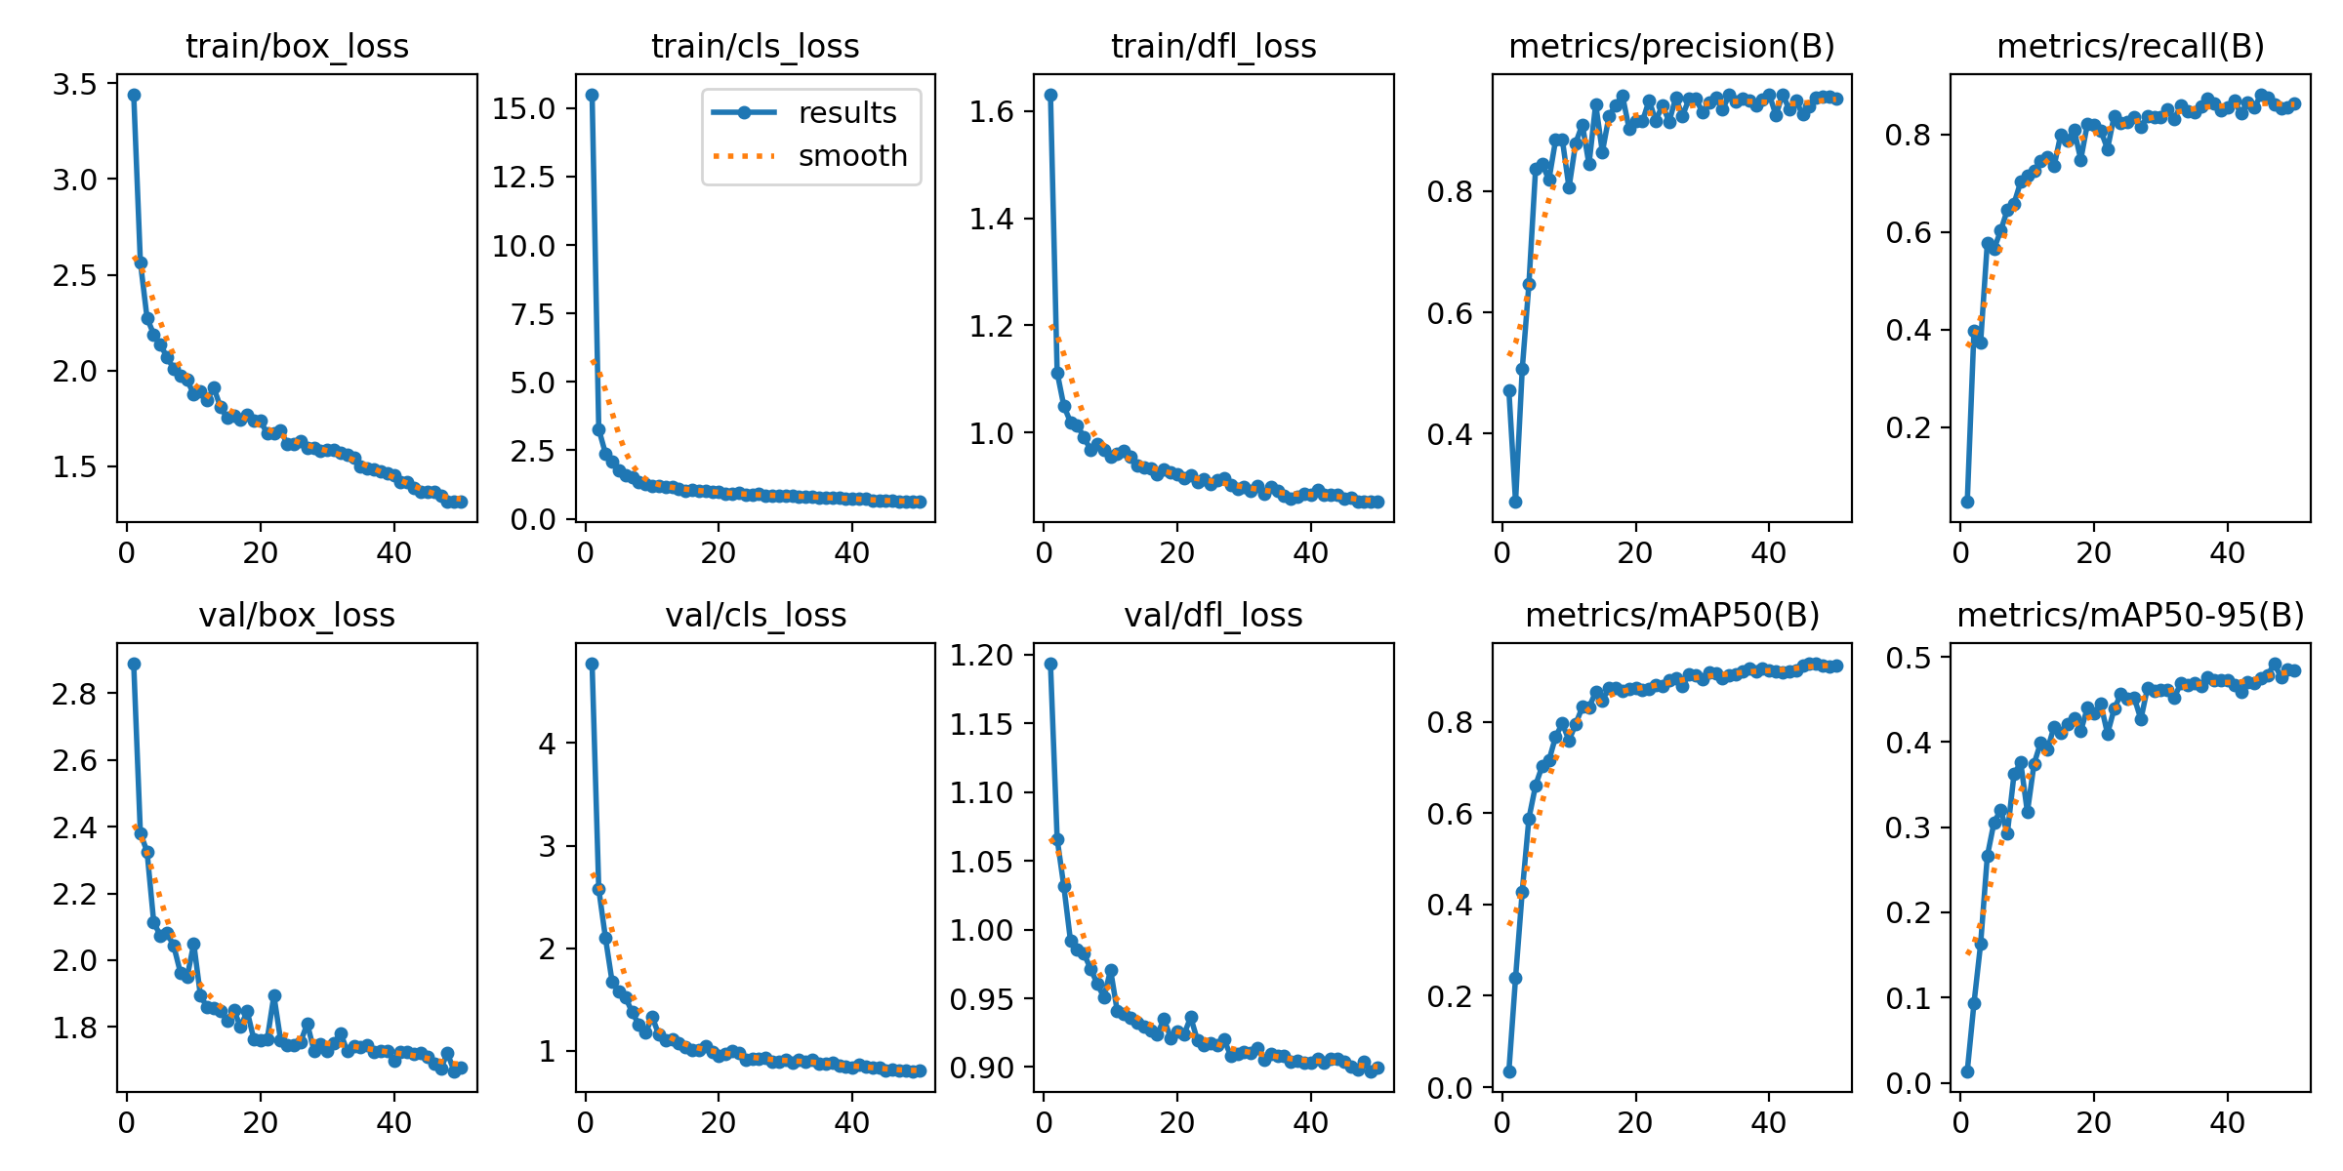
2. Yolov8s with finetunning Result graph
During freezing parameter’s phase
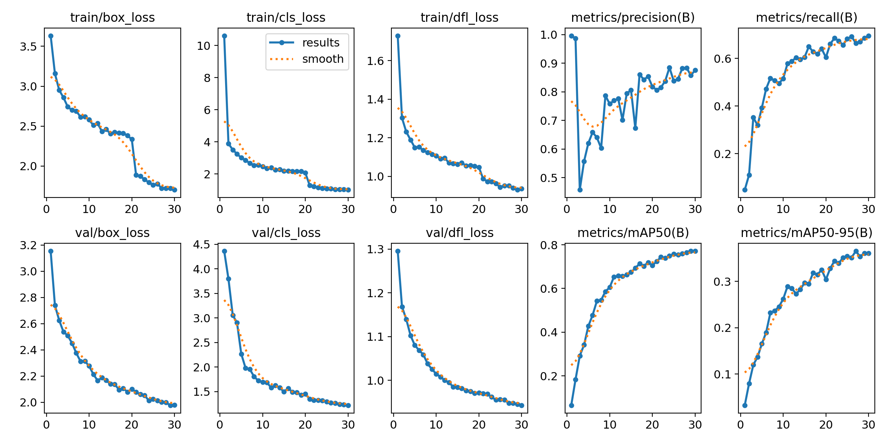

After Fine-tunning phase
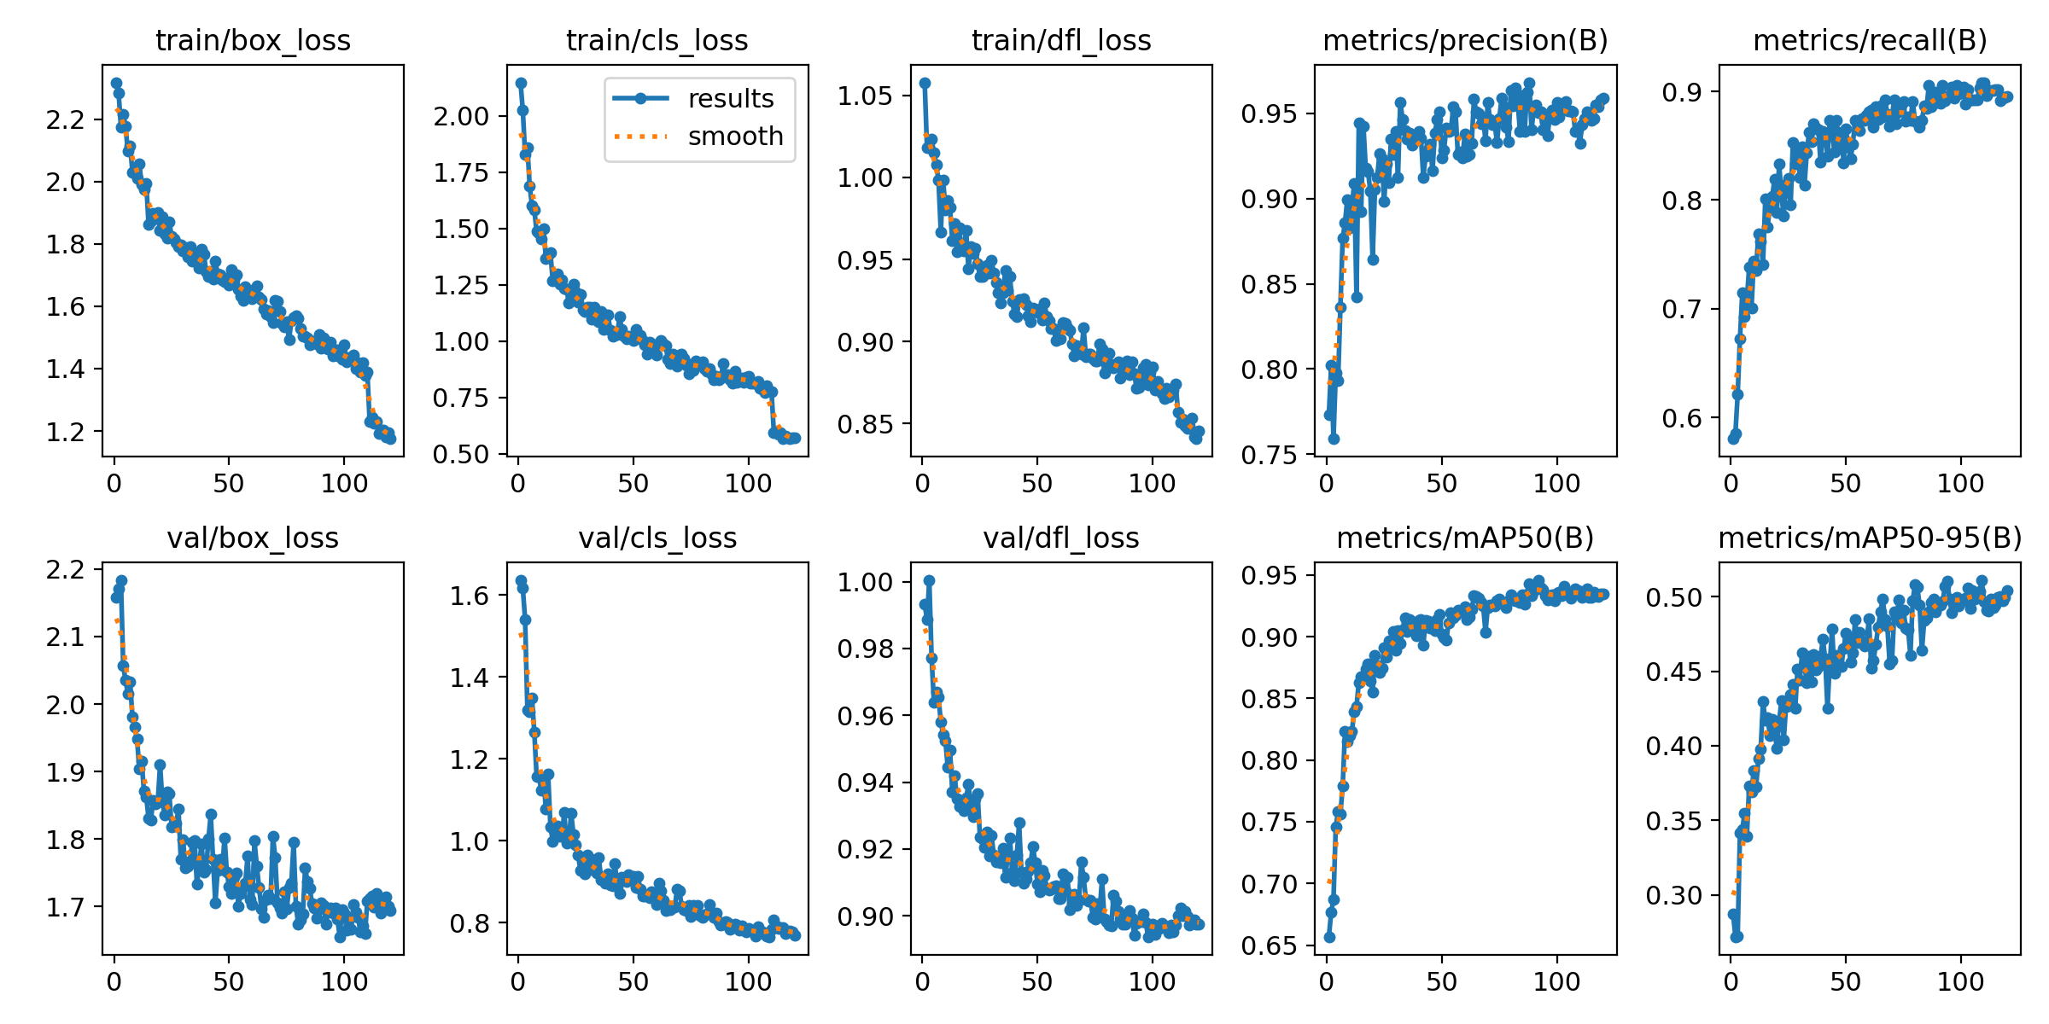
3. Yolov8m model Result graph


Conclusion
The project successfully built a complete defect detection pipeline, starting from dataset preprocessing to model training and evaluation. The optimized YOLOv8-M model produced reliable defect detection results across all PCB defect categories. The system is ready for deployment and further extension into real-time quality inspection workflows.

